Dolgin Upgrades 4-Position Battery Charger for Sony EX Series Cameras by adding the TDM (test module)

June 1, 2017
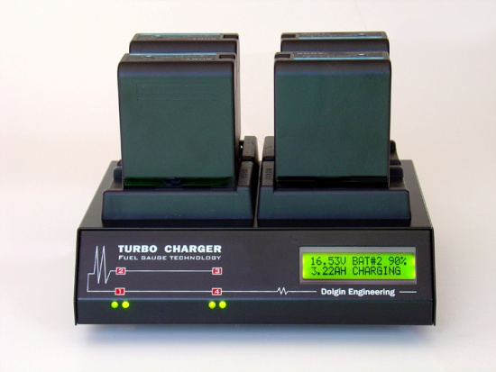
Lexington, MA – Dolgin Engineering, a leading provider of fast multi position battery chargers and DC power adapters announced the release of a new upgraded 4-position battery charger for Sony BP-U30/BP-U60/BP-U90 and Non-OEM batteries
Designed for video production studios and rental facilities, the unit is designed to provide fast, reliable charging of multiple BP-UXX camera batteries for both in-house and field use.
According to company president Alex Dolgin, “Due to the great success of our TC400-EX model, we’ve responded to numerous requests to add the test module (TDM), so that the batteries could be cycled/tested under real world use conditions”.
The new TC400-EX-TDM model adds test functionality to all the standard features of TC-400-EX below:
- Fast, safe simultaneous charging of BP-U30 and BP-U60 packs.
- Digital LCD display indicates the battery pack capacity.
- As a battery being charged, charge status is displayed in Volts, Ah, and percent of charge
- Each of the 4 channels is fully independent of the other.
- TDM cycles the battery inserted in position 1, providing a report on its capacity after fully charging and discharging
- Worldwide 100-240V AC power.
- Sleek, small and lightweight package (WxHxD) 8.4" x 2.5" x 6.6".
- Designed and manufactured in the USA.
The TC400-EX also features a highly efficient smart charging circuit. “It takes only about 4 hours to charge a high capacity battery pack. The pack can be left on the charger after the charge is complete,” said Dolgin.
For more information visit Dolgin Engineering www.dolgin.net or call 781 863-1813

